Technological Institute of the Philippines

938 Aurora Blvd. Cubao, Quezon City

College of Information Technology Education

IT 004 – Web Systems and Technologies

Preliminary Period

Designing Web Pages using HTML and CSS

|  |  |
| --- | --- |
| Name: BUENAVENTURA, ARISTOTLE C.  CACHILA, JULIUS EDREEN H. | Date: OCTOBER 14, 2021 |
| Program / Section: WEB SYSTEMS AND TECHNOLOGIES / BSIT21S1 | Instructor: Ms. Roxanne A. Pagaduan |
| Assessment Task: Practice Set No. 1 | |

**Instructions:**

* Provide screenshots to satisfy the requirements.
* Include your FULLNAME in every screenshot.
* Include a brief description in each screenshot.
* Save your work as **SURNAME1_SURNAME2_PS1.DOC** (Ex. PAGADUAN_ANCHETA_PS1.DOC and .PDF)

**Overview:**

HTML stands for Hyper Text Markup Language. It is a markup language for creating web pages and other information that can be viewed in a web browser. HTML is not a programming language since it uses a markup tags to describe web pages. HTML tags are used to interpret the content of the page in which the browser reads as the HTML documents and displays them as a web page. HTML tags can come in pairs the first tags for the start and the next tags is for end part and surrounded by <angle-brackets>.

HTML element indicates structure in an HTML document. More specifically, it is an SGML element that meets the requirements of one or more of the HTML Document Type Definitions (DTDs). HTML elements generally consist of three parts: a *start tag* marking the beginning of an element, some amount of *content*, and an *end tag*. Elements may represent headings, paragraphs, hypertext links, lists, embedded media, and a variety of other structures.

Cascading Style Sheets or known as CSS is a style sheet that allows the developer or the user to change and modify the looks and style of the webpage. It is one of the important parts of the webpage that allows the creator of the webpage to easily modify their webpage by accessing the CSS file and the html document that will read the CSS file and change the style and the looks of the webpage accordingly. Updating a webpage can be much easier because only the part that the creator needs to modify is the CSS file and not the whole HTML code and with this it avoids errors caused by editing the html code.

**Requirements:**

1. Create a web document that contains the lyrics of your favorite song. Use the following CSS properties: background, padding, margin, border and font. (save your work as PS1-lyrics.html)

Sample Output:

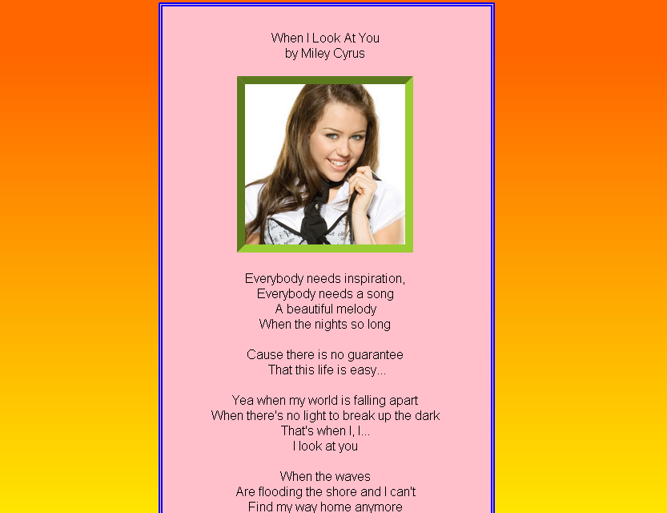

1. Create a homepage for the flower shop using HTML and CSS. *(****note:*** *you can download any related images on the internet)*. Acknowledge references. Save your work as PS1-flowershop.html

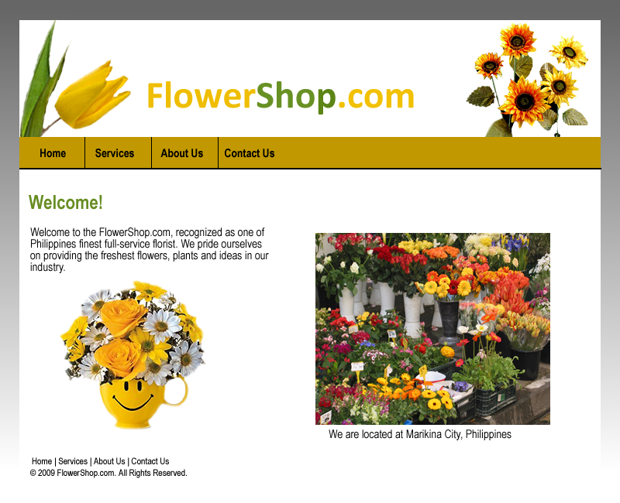

**Assessment Tool:**

This assessment will be graded using the Rubric for Laboratory Performance in Web Systems and Technologies.

**Answer:**

**Source Code:**

**SOURCE CODE FOR PS1-LYRICS.HTML**

<!DOCTYPE html>

<html>

<head>

<meta charset="utf-8" />

<title> Lyrical Page </title>

<link rel="stylesheet" type="text/css" href="PS1-lyrics.css">

<link rel="stylesheet" href="https://fonts.googleapis.com/css?family=Bitter">

<link rel="stylesheet" href="https://fonts.googleapis.com/css?family=Martel">

</head>

<body>

<header>

<nav class="header">

<ul>

<input type="text" name="search" placeholder="Search"> </input>

<li> <a> Home </a> </li>

<li> <a> Featured </a> </li>

<li> <a> Videos </a> </li>

<li> <a> Shop </a> </li>

</ul>

</nav>

</header>

<div class="paper">

<div class="topSide">

<h1> Slow Dancing In The Dark </h1>

<h2> Joji </h2>

</div>

<div class="previewImg">

<img id="joji" src="../PS1-lyrics/imgs/ballads1.jpg">

<h3><a>Ballads 1</a></h3>

</div>

<pre>

[Verse 1]

I don't want a friend (Just one more night)

I want my life in two (My life in two)

Please one more night

Waiting to get there

Waiting for you (Waiting for you)

Just one more night

I'm done fighting all night

[Pre-Chorus 1]

When I'm around slow dancing in the dark

Don't follow me, you'll end up in my arms

You done made up your mind

I don't need no more signs

Can you?

Can you?

[Chorus]

Give me reasons we should be complete

You should be with him, I can't compete

You looked at me like I was someone else, oh well

Can't you see? (Can't you see?)

I don't wanna slow dance (I don't wanna slow dance)

In the dark, dark

[Verse 2]

When you gotta run

Just hear my voice in you (My voice in you)

Shutting me out you (Shutting me out)

Doing so great (So great, so great)

You

[Pre-Chorus 2]

Used to be the one to hold you when you fall

Yeah, yeah, yeah (When you fall, when you fall)

I don't ---- with your tone (I don't ---- with your tone)

I don't wanna go home (I don't wanna go home)

Can it be one night?

Can you?

Can you?

[Chorus]

Give me reasons we should be complete

You should be with him, I can't compete

You looked at me like I was someone else, oh well

Can't you see?

I don't wanna slow dance (I don't wanna slow dance)

In the dark, dark

In the dark, dark

</pre>

<div class="bot">

<audio controls>

<source src="SDITD.mp3" type="audio/mp3"></src>

</audio>

<img id="sditd" src="../PS1-lyrics/imgs/SDITD.jpg">

</div>

</div>

</body>

</html>

**SCREENSHOT FOR PS1-LYRICS.HTML**

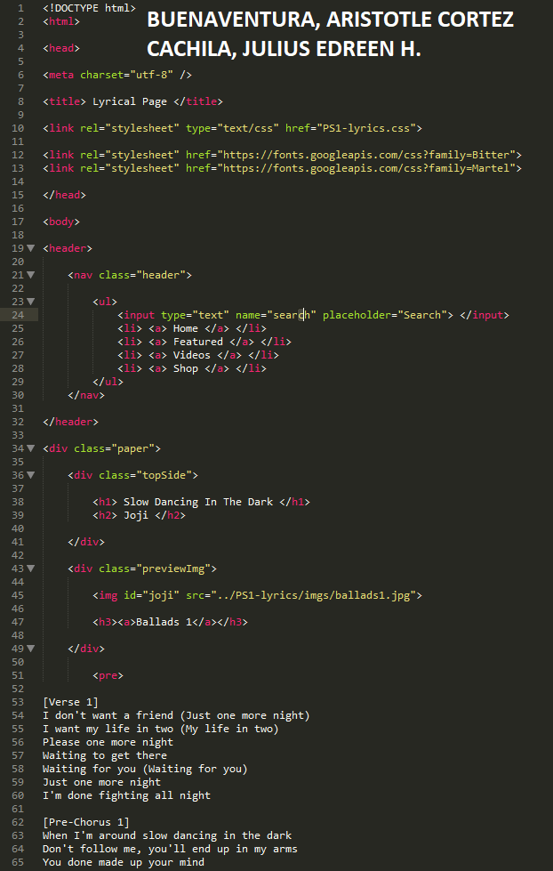

On the previous screenshot, the programmer inherits a link for it to call the external CSS. It also inherited a link for a font to use. The programmer used the <header> for their header. Listing down four lists and a search bar for nav. A programmer then created a div for the structure like paper and correctly displayed the title on the top part.

The first half can also be seen here, and to make it similar to poem type, the programmer used the command <pre>

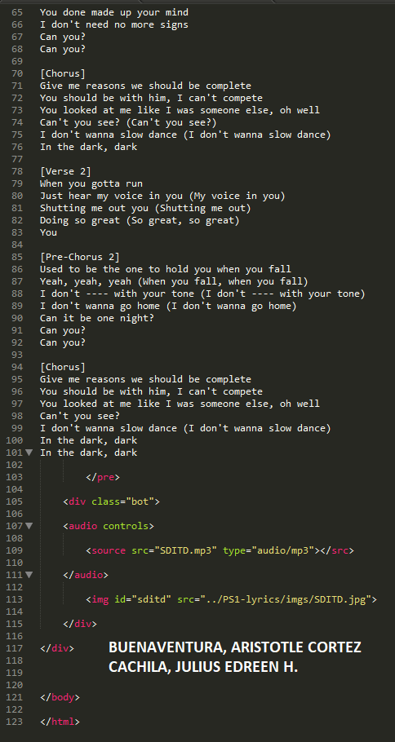

Here, we can see the continued lyrics until it is finished. The programmer then used a div with the class name “bot” to exhibit the bottom part of the paper-like structure. The programmer added an image and the audio for the precisely chosen music.

**SOURCE CODE FOR PS1-LYRICS.CSS**

body

{

background-image: linear-gradient(white, black);

background-repeat: no-repeat;

}

.header

{

font-family: "Bitter";

width: 100%;

margin-bottom: 20px;

}

input

{

margin-top: 7px;

margin-right: 80px;

float: right;

border: 2px solid black;

height: 25px;

width: 250px;

}

ul

{

list-style-type: none;

margin: 0;

padding: 0;

overflow: hidden;

background-color: #741126;

}

li

{

float: left;

}

li a

{

display: block;

color: white;

text-align: center;

text-decoration: none;

padding: 15px 15px;

}

li a:hover

{

background-color: #d2657c;

text-decoration: underline;

}

.paper

{

font-family: "Didot";

border: 5px solid #040707;

background-color: #EED6D3;

padding: 5px;

height: 100%;

width: 50%;

margin: auto;

}

.topSide

{

border: 8px solid black;

font-family: "Martel";

font-size: 16px;

text-decoration: bold;

text-align: center;

text-shadow: -1px -1px white;

background-image: linear-gradient(#f70839, #f81646, #6f0118);

padding: 8px;

width: 60%;

margin-left: 50px;

margin-top: 30px;

}

.previewImg

{

float: right;

margin-top: -179px;

margin-right: 100px;

border: 5px solid black;

width: 150px;

height: 150px;

}

h3

{

text-decoration: underline;

text-align: center;

margin-top: -1px;

}

#joji

{

height: 150px;

width: 150px;

}

pre

{

text-align: center;

font-size: 25px;

}

.bot

{

text-align: center;

border: 5px solid black;

background-color: black;

height: 53px;

}

audio

{

width: 80%;

}

#sditd

{

border: 1px solid white;

margin-left: 20px;

float: left;

height: 50px;

width: 50px;

}

**SCREENSHOT FOR PS1-LYRICS.CSS**

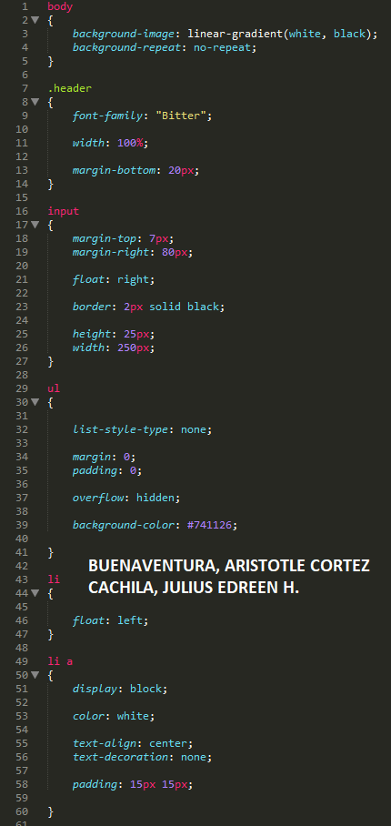

The user uses a variety of styles and commands. Firstly, on the body, the programmer used a gradient for decoration. On the .header a class, the programmer prompts it for constructing the header size and placement. The Input is the one that can be seen on the upper right; fix it so that it fits there. The ul is for the nav and decorated to how it will be exhibited. The li with float: left; is the one that places the nav on the left side of the nav. The li a, is the one that sets them accordingly with proper indentions and decorations.

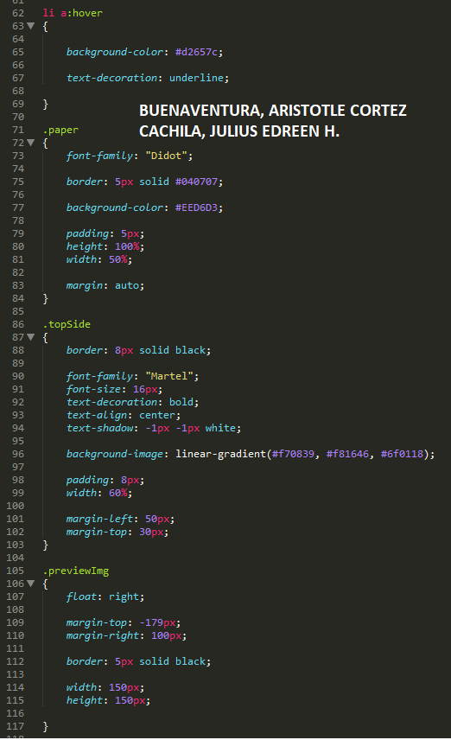

The li a:hover is just some trick so that whenever a user hovers unto it, the bg-color will change as long as it has an underline. The .paper is for designing the paper-like structure properly as to how the lyrics are shown there. The .topside is designing the title and the artist on the uppermost part. The .previewImg is for displaying the image of the album.

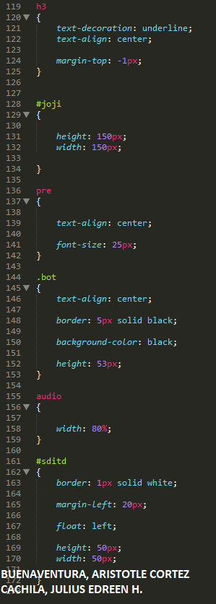

The h3 is for designing the album name. The #joji is for fixing the size of the image. The pre is the one that displays the lyrics in the middle and sets their font size. The .bot is for aligning the bottom part as well as designing them. The audio is for fixing its width. And finally, the #sditd is for fixing the image found on the left side of the audio.

**SOURCE CODE FOR PS1-LYRICS.HTML**

<!DOCTYPE html>

<html lang="en">

<head>

<meta charset="utf-8">

<meta name="viewport" content="width=device-width,initial-scale=1.0">

<link rel="stylesheet" type="text/css" href="style.css">

<title>The Flower Shop</title>

<link href="https://fonts.googleapis.com/css2?family=Catamaran:wght@100&amp;display=swap" rel="stylesheet">

<link href="https://fonts.googleapis.com/css2?family=Jacques+Francois+Shadow&display=swap" rel="stylesheet">

</head>

<body>

<header>

<a href="PS1-flowershop.html" class="header-brand">FlowerShop.com</a>

<nav>

<ul>

<li><a href="PS1-flowershop.html">Home</a></li>

<li><a href="PS1-flowershop.html">Sevices</a></li>

<li><a href="PS1-flowershop.html">About Us</a></li>

<li><a href="PS1-flowershop.html">Contact Us</a></li>

</ul>

</nav>

</header>

<div class="header">

<section class="index-banner">

<h1>Welcome to FlowerShop.com!</h1>

<h2>Welcome to the FlowerShop.com recognized as one of Philippines finest full-service florist.

We pride ourselves on providing the freshnest flowers, plants, and ideas in our industry.

We are located in Marikina City, Philippines</h2>

</section>

</div>

<div class="contentContainer" id="rose">

<div class="image"><img src="imgs/rose.jpg"></div>

<div class="contentTitle">

<p>La Vie En Rose</p>

<div class="button1">

<button onclick="openModel('myModal')">View more</button>

<div id="myModal" class="modal">

<div class="modal-content">

<span class="close">&times;</span>

<h1>La Vie En Rose</h1>

<p>A sweet surprise that you can give any day of the week for any occasion without having to

break the bank! A beautiful and simple bouquet that can sweeten the birthday celebrant,

make someone smile as a sorry gift, or delight your significant other!</p>

<h2>Blooms:</h2>

<p>Red Roses</p>

<p>Light Pink Roses</p>

<p>Dark Pink Roses</p>

<p>Alstromeria White</p>

<h2>Price: &#8369; 5,990</h2>

</div>

</div>

</div>

</div>

</div>

<div class="contentContainer" id="romance">

<div class="contentTitle">

<p>Hot Romance</p>

<div class="button1">

<button onclick="openModel('bravoModal')">View more</button>

<div id="bravoModal" class="modal">

<div class="modal-content">

<span class="close">&times;</span>

<h1>Hot Romance</h1>

<p>Up the romance with this beautiful and classic

arrangement of red roses that is hand wrapped to perfection!

If you're looking to make someone smile on any occasion without

breaking the bank, this bouquet is your best bet!</p>

<h2>Blooms:</h2>

<p>Red Roses</p>

<p>White Statice</p>

<p>Tea leaf</p>

<h2>Price: &#8369; 6,990</h2>

</div>

</div>

</div>

</div>

<div class="image"><img src="imgs/romance.jpg"></div>

</div>

<div class="contentContainer" id="lily">

<div class="image"><img src="imgs/lily.jpg"></div>

<div class="contentTitle">

<p>Lovely Lillian</p>

<div class="button1">

<button onclick="openModel('charlieModal')">View more</button>

<div id="charlieModal" class="modal">

<div class="modal-content">

<span class="close">&times;</span>

<h1>Lovely Lillian</h1>

<p>Beautiful pink lilies, decorated with red berries, golden rod,

and papua leaves; our Lovely Lillian flower bouquet is a sweet

gesture to make someone's day bright, blooming, and beautiful.</p>

<h2>Blooms:</h2>

<p>Berry Red</p>

<p>Pink Lily</p>

<h2>Price: &#8369; 8,990</h2>

</div>

</div>

</div>

</div>

</div>

<div class="contentContainer" id="sun">

<div class="contentTitle">

<p>Sunday Sun</p>

<div class="button1">

<button onclick="openModel('deltaModal')">View more</button>

<div id="deltaModal" class="modal">

<div class="modal-content">

<span class="close">&times;</span>

<h1>Sunday Sun</h1>

<p>Bask in the light of our Sunday Sunflower arrangement -

a bouquet brimming with purple statice flowers, soi, and

papua leaves, with a bright golden sunflower right in between.

Send this beautiful flower bouquet to someone, and brighten up their day.</p>

<h2>Blooms:</h2>

<p>Sunflower</p>

<p>Statice Purple</p>

<h2>Price: &#8369; 9,990</h2>

</div>

</div>

</div>

</div>

<div class="image"><img src="imgs/sun.jpg"></div>

</div>

<script>

function openModel (modalId) {

var modal = document.getElementById(modalId);

var close = modal.getElementsByClassName("close")[0];

modal.style.display = "block";

close.onclick = function() {

modal.style.display = "none";

}

window.onclick = function(event) {

if (event.target == modal) {

modal.style.display = "none";

}

}

}

</script>

</div>

<footer class="footer">

<div class="footer-nav">

<ul>

<li><a href="PS1-flowershop.html">Home</a></li>

<li><a href="PS1-flowershop.html">Sevices</a></li>

<li><a href="PS1-flowershop.html">About Us</a></li>

<li><a href="PS1-flowershop.html">Contact Us</a></li>

</ul>

</div>

<h4>&copy; 2021 FlowerShop.com. All Rights Reserved.</h3>

</footer>

</body>

</html>

**SCREENSHOT FOR PS1-FLOWERSHOP.HTML**

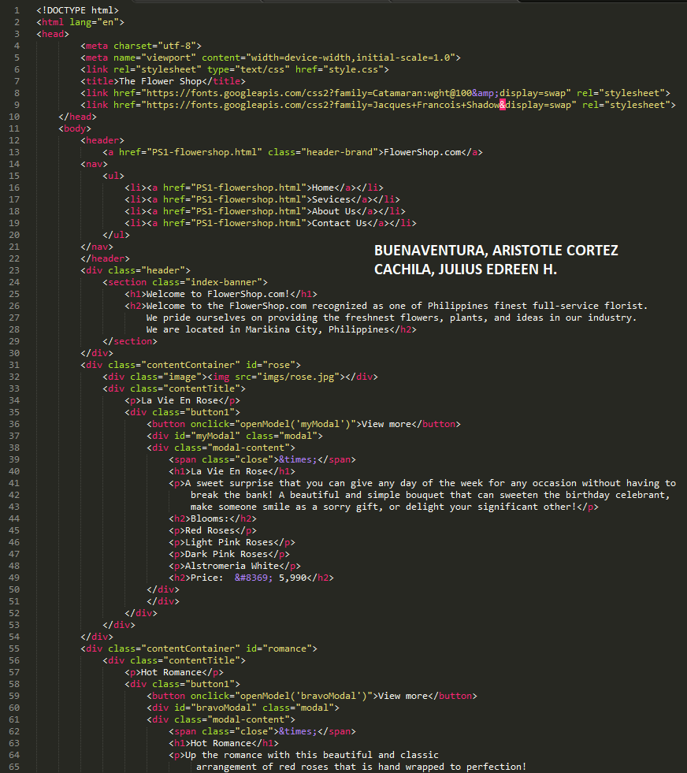

The programmer imports a different font style for the header title. There are four unordered lists inside the navigation. The webpage also has a banner where the welcome message is placed. The programmer sets only four flower bouquets to showcase that the programmer satisfies the assignment's requirements. The flower's name is placed side by side alternately, and the description of each bouquet is placed in the pop-up window.

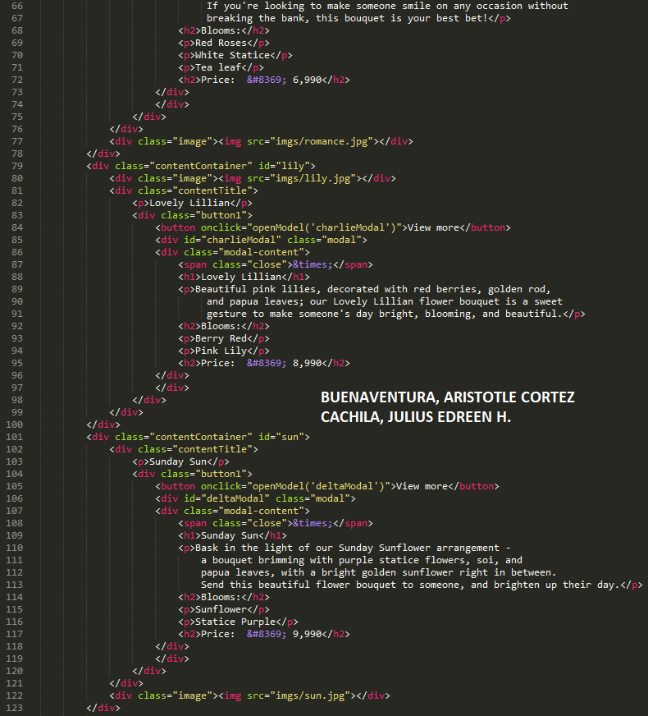

The programmer also input the image of each bouquet for the customer to easily visualize what flower they want to order. The included blooms and prices are also included inside the description in the pop-up window.

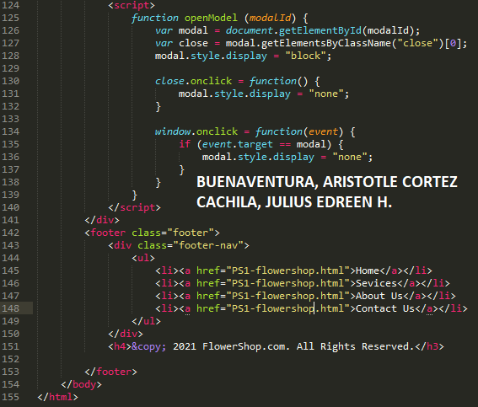

The programmer implements a function that will make a pop-up window for the description of the bouquet.

**SOURCE CODE FOR STYLE.CSS**

body {

font-family: 'Catamaran', sans-serif;

background-color: #fefefe;

width: 100%;

margin: 0;

}

a:hover {

color: white;

}

header {

position: fixed;

top: 0;

right: 0;

left: 0;

background-color: #8d8741;

width: 100%;

height: 100px;

z-index: 1;

padding: 34px 0;

padding-top: 0;

}

header .header-brand {

font-family: 'Jacques Francois Shadow', cursive;

font-size: 35px;

color: #111;

display: block;

margin: auto;

text-align: center;

padding: 20px;

text-decoration: none;

}

.header h1{

font-family: 'Anton', sans-serif;

color: #ddd388;

font-size: 50px;

text-shadow: 3px 3px black;

margin-block-start: 0;

margin-block-end: 0;

margin-top: 100px;

}

.header h2{

font-family: 'Anton', sans-serif;

color: #ddd388;

font-size: 30px;

width: 60%;

text-align: center;

text-shadow: 2px 2px black;

margin: auto;

margin-block-start: 0;

margin-block-end: 0;

margin-top: 20px;

}

nav ul {

display: block ;

font-size: 16px;

margin: 0 auto;

width: fit-content;

}

nav ul li {

display: inline-block;

padding-right: 100px;

}

nav ul li a {

font-family: 'Catamaran', sans-serif;

font-weight: 900;

color: #111;

text-decoration: none;

}

.index-banner{

width: 100%;

background-image: url("imgs/banner.jpg");

background-size: cover;

background-repeat: no-repeat;

height: 400px;

background-position: center;

margin-top: 134px;

align-items: center;

justify-content: center;

text-align: center;

display: inline-block;

transition-property: all;

transition-duration: 4s;

transition-timing-function: ease-in-out;

}

.index-banner:hover {

background-image: url("imgs/banner2.jpg");

}

.contentContainer {

width: 100%;

display: flex;

flex-wrap: wrap;

}

.contentContainer .image {

width: 50%;

}

.contentContainer img {

height: 500px;

max-width:100%;

width:100%;

}

.contentContainer .contentTitle {

font-weight: bold;

font-size: 40px;

text-align: center;

font-style: italic;

padding-top: 150px;

width: 50%;

}

.contentContainer a {

color: black;

text-decoration: none;

}

.contentContainer a:hover {

text-decoration: underline;

color: white;

}

.modal {

display: none;

position: fixed;

z-index: 1;

padding-top: 50px;

left: 0;

top: 0;

width: 100%;

height: 100%;

overflow: auto;

background-color: rgb(0,0,0);

background-color: rgba(0,0,0,0.4);

}

.modal-content {

background-color: #fefefe;

margin: auto;

padding: 20px;

border: 1px solid #888;

width: 80%;

font-size: 20px;

text-align: justify;

}

.modal-content h1 {

text-align: center;

}

.close {

color: #aaaaaa;

float: right;

font-size: 28px;

font-weight: bold;

}

.close:hover, .close:focus {

color: #000;

text-decoration: none;

cursor: pointer;

}

footer {

background-color: #BC986A;

color: white;

font-size: 16px;

padding-top: 30px;

padding-bottom: 30px;

padding-left: 0;

overflow: hidden;

width: 100%;

text-align: center;

line-height: 1.5;

display: inline-block;

}

.footer-nav{

display: inline-block;

}

.footer-nav ul {

list-style-type: none;

margin: 0;

padding: 0;

overflow: hidden;

}

.footer-nav li {

float: left;

}

.footer-nav li a {

display: block;

color: black;

text-align: center;

padding: 14px 16px 0 16px;

text-decoration: none;

}

.footer-nav li a:hover {

color: white;

}

.footer-nav h4 {

margin-top: 0;

**SCREENSHOT FOR PS1-FLOWERSHOP.CSS**

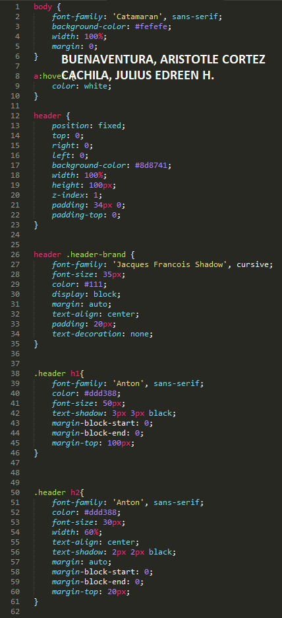

The Header is fixed on the top of the web. The programmer set the z-index of the Header to 1, so it will overlap with other elements. The h1 and h2 have different attributes like font size and designs.

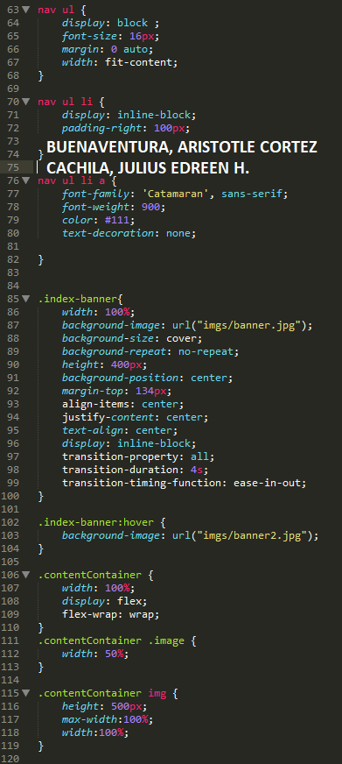

The banner on the webpage has a hover effect where when the user hovers the cursor on the banner; the banner image will change to another image.

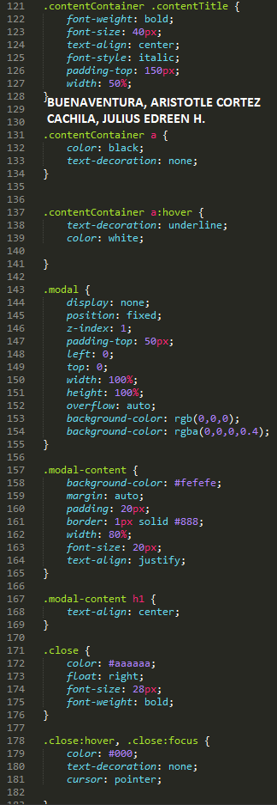

The purpose of the modal here is for the pop-up window for the description of each bouquet. The programmer sets its z-index to 1, so it will overlap with other elements.

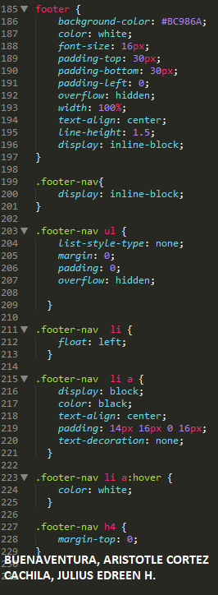

Lastly, the programmer manipulates the attributes of the footer so it will look nice. They change the background color to suit the whole page's color theme, implement a hover effect for each navigation, and arrange them side by side.

**Sample Output:**

**OUTPUT FOR PS1-LYRICS.HTML**

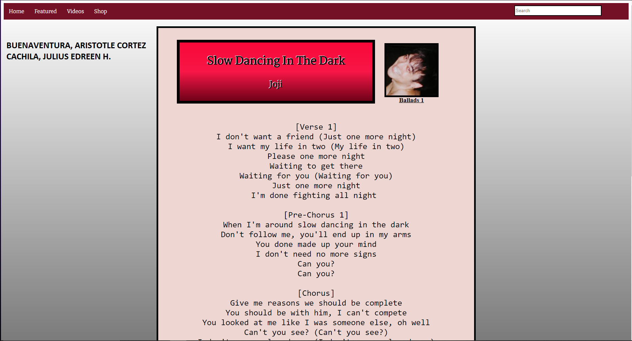

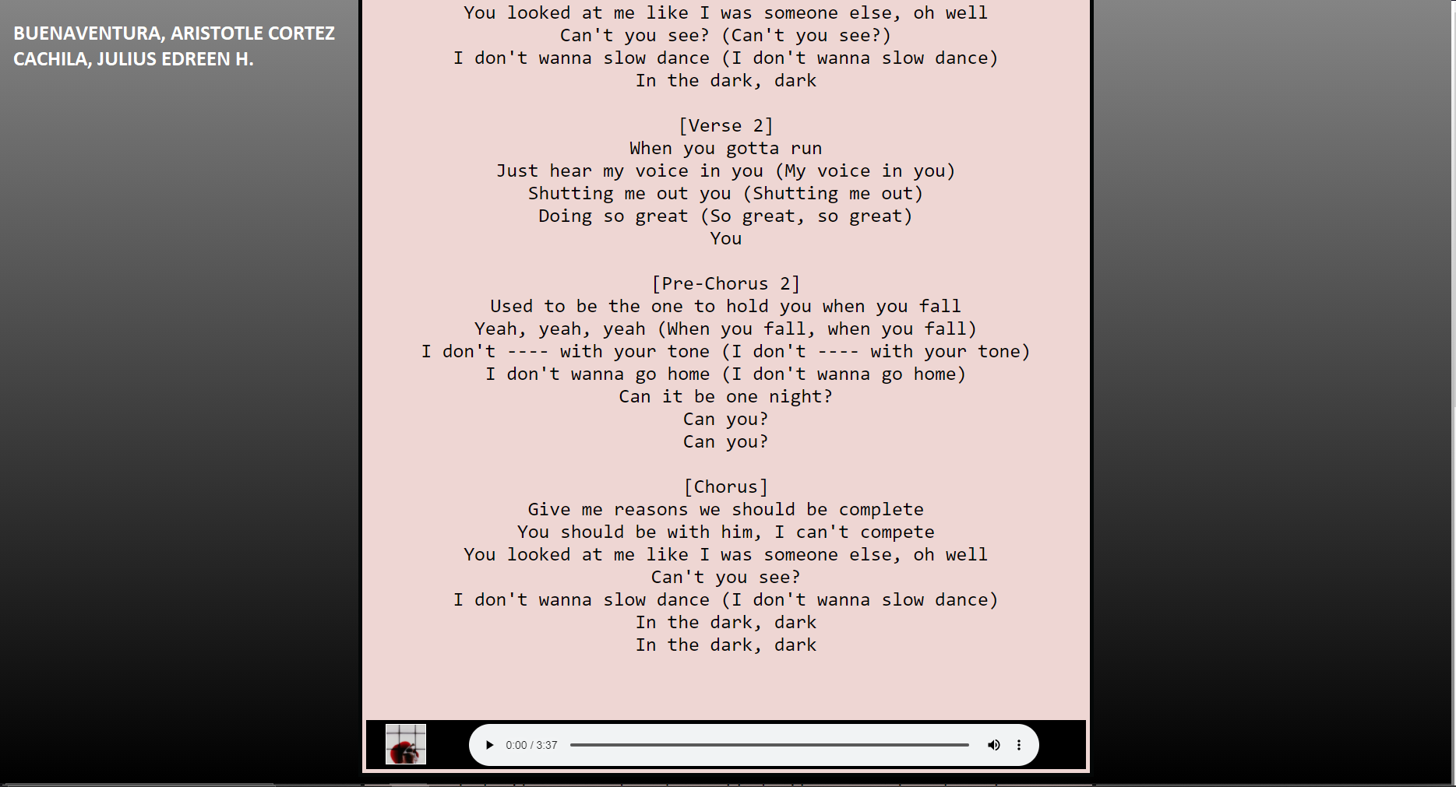

Reference: https://genius.com/Joji-slow-dancing-in-the-dark-lyrics

**OUTPUT FOR PS1-FLOWERSHOP.HTML**

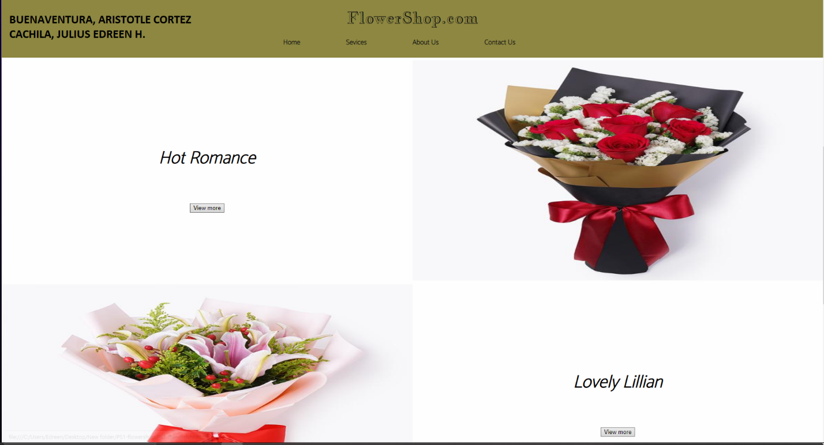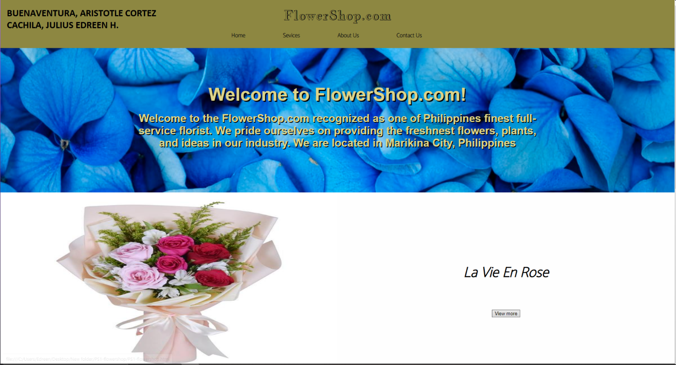

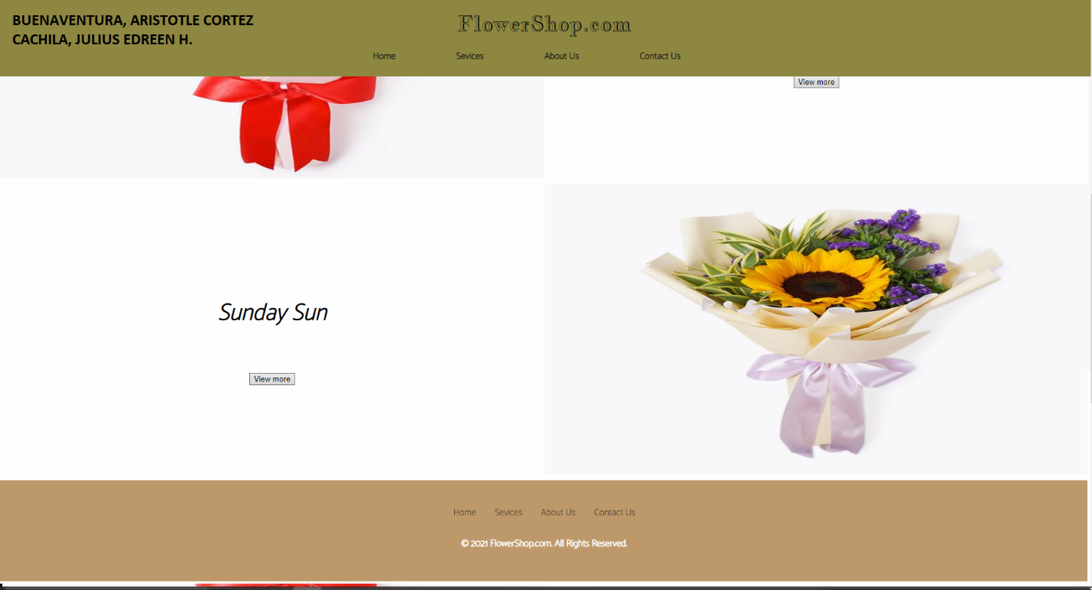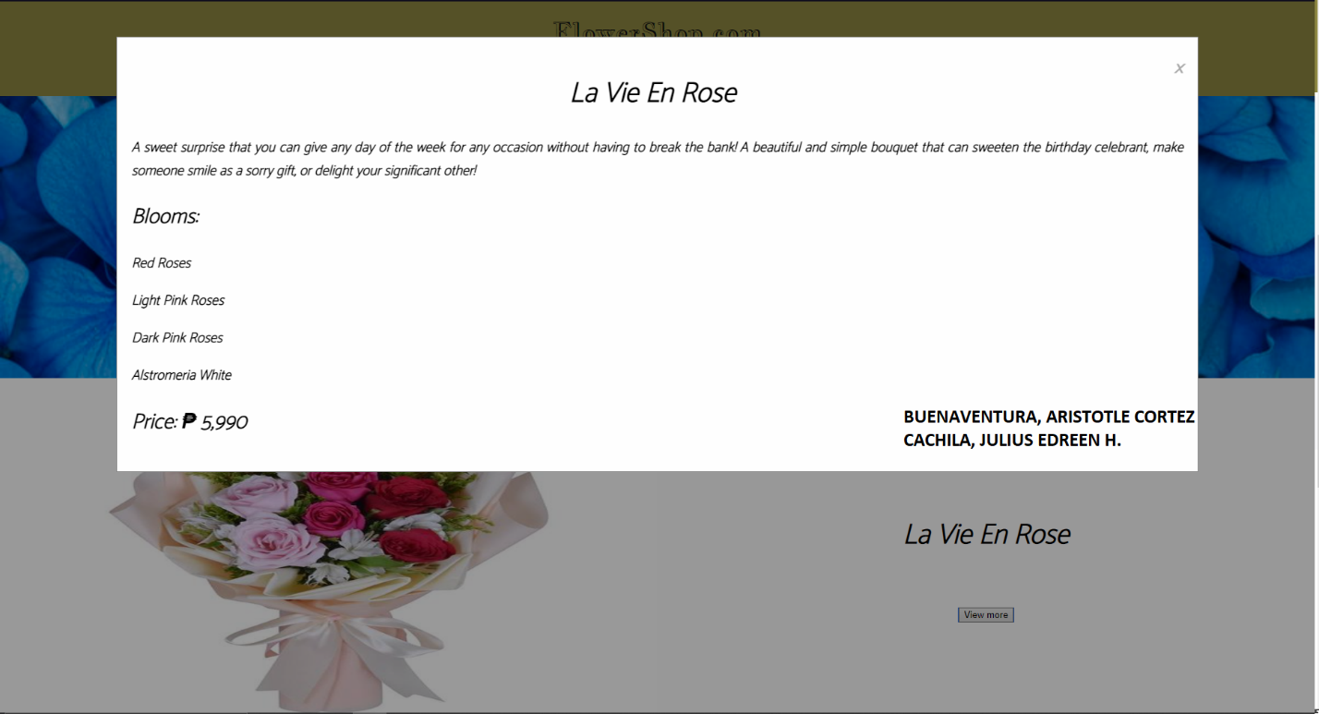

Reference: <https://www.flowerchimp.com.ph>

**Honor Pledge:**

"We affirm that we have not given or received any unauthorized help on this assignment, and that this work is our own"